MEM STORAGE 8

ZEXP FUNCTION RN1,C12

0,0/.2,.22/.4,.51/.5,.69/.6,.92/.7,1.2/.8,1.61

.9,2.3/.95,3/.99,4.6/.999,6.9/1,100

GENERATE 2,FN$ZEXP,,500

TEST L Q$A11,5,POTERI

QUEUE A11

ENTER MEM,1

DEPART A11

MET6 QUEUE A2

TRANSFER BOTH,MET1,MET2

MET1 SEIZE CPU1

DEPART A2

ADVANCE 5,FN$ZEXP

RELEASE CPU1

TRANSFER,MET3

MET2 SEIZE CPU2

DEPART A2

ADVANCE 1,FN$ZEXP

RELEASE CPU2

MET3 TRANSFER .6,MET5,MET4

MET4 QUEUE A3

SEIZE DISK

DEPART A3

ADVANCE 5,3

RELEASE DISK

TRANSFER,MET6

MET5 LEAVE MEM,1

TRANSFER ,VIHOD

POTERI TERMINATE

VIHOD TERMINATE

GENERATE 300

TERMINATE 1

START 500

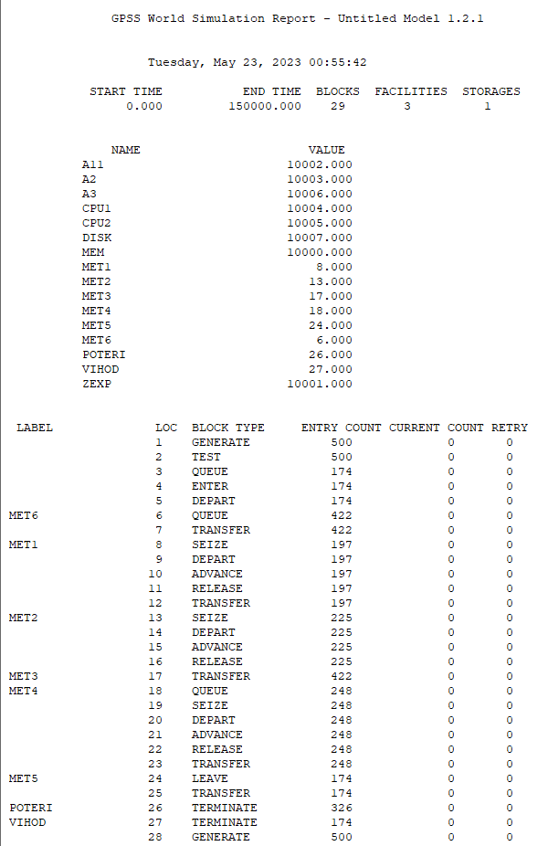

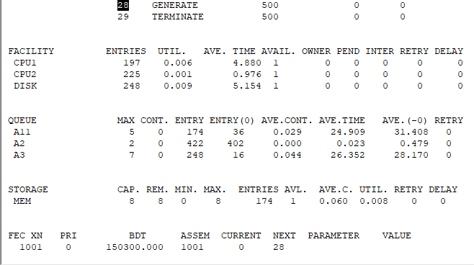

ZEXP FUNCTION RN1,C12 0,0/.2,.22/.4,.51/.5,.69/.6,.92/.7,1.2/.8,1.61

.9,2.3/.95,3/.99,4.6/.999,6.9/1,500

GENERATE 6,FN$ZEXP

TRANSFER .2,MET2,MET1

MET2 TRANSFER .25,MET4,MET3

MET4 TRANSFER .333,MET6,MET5 MET6 TRANSFER .5,MET8,MET7

MET1 TEST L Q$OCH1,5,OUT QUEUE OCH1

SEIZE DISK1 DEPART OCH1 ASSIGN 1,DISK1 ADVANCE 25,25 TRANSFER ,MET9

MET3 TEST L Q$OCH2,5,OUT QUEUE OCH2

SEIZE DISK2 DEPART OCH2 ASSIGN 1,DISK2 ADVANCE 25,25 TRANSFER ,MET9

MET5 TEST L Q$OCH3,5,OUT QUEUE OCH3

SEIZE DISK3 DEPART OCH3 ASSIGN 1,DISK3 ADVANCE 25,25 TRANSFER ,MET9

MET7 TEST L Q$OCH4,5,OUT QUEUE OCH4

SEIZE DISK4 DEPART OCH4 ASSIGN 1,DISK4

ADVANCE 25,25 TRANSFER ,MET9

MET8 TEST L Q$OCH5,5,OUT QUEUE OCH5

SEIZE DISK5 DEPART OCH5 ASSIGN 1,DISK5 ADVANCE 25,25 TRANSFER ,MET9

MET9 QUEUE OCH6 SEIZE CAN

DEPART OCH6 ADVANCE 7,7 RELEASE CAN RELEASE P1 TERMINATE OUT TERMINATE

GENERATE 150000

TERMINATE 1

START 1

